A.H. Morton Scholarship for Doctoral Research in Classical Persian Studies

The Gibb Memorial Trust is pleased to advertise the Annual Scholarship in memory of Alexander (Sandy) Morton for doctoral research in the area of classical Persian Studies. Sandy Morton (1942-2011) worked at the British Museum and as Senior Lecturer in Persian at the London School of African and Oriental Studies. His interests ranged widely over the field, from glass weights and numismatics to Persian literature and the history of Iran from the Saljuqs to the Safavids. He was a long-standing Trustee of the Gibb Memorial Trust.

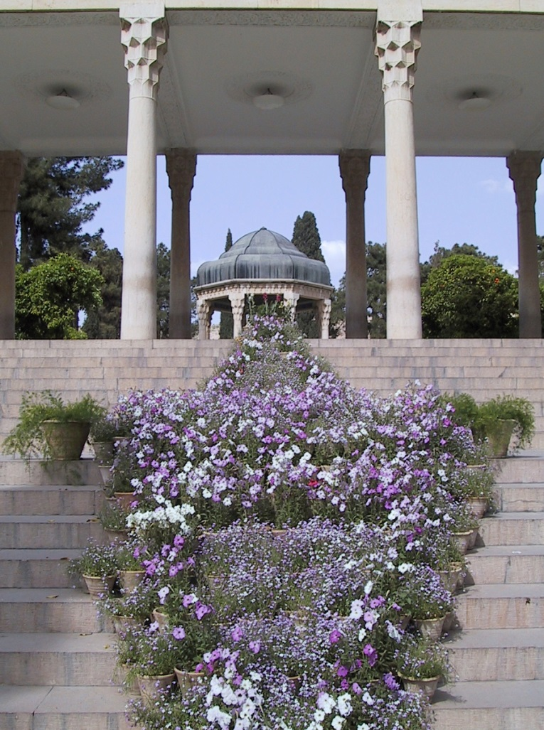

The award is for a maximum of £3,000 and can be applied to any year up to the final completion of a course of doctoral study at a British university, including for an approved period of study abroad; it will be paid at the start of the academic year in question, up to the submission of the dissertation.

The Gibb Memorial Trust http://www.gibbtrust.org was founded in 1902 to commemorate Elias John Wilkinson Gibb. He devoted his life to researching the history, literature, philosophy and religion of the Turks, Persians and Arabs and the objectives of the Trust are to promote the study and advancement of these topics.

Eligibility:
The award is open to all students undertaking doctoral research at a British university in the field of classical Persian studies, loosely defined to embrace Persian literature and history of the pre-modern era but not excluding other areas of study.

Recipients of the award will not be eligible to reapply another year. Those unable to take up an award will need to reapply.

Applications:

- Should be submitted in writing and sent by post or email to the address below;
- Should be received not later than 31 March for the academic year starting the following October;
- Should include proof of application or of acceptance to study on a course of doctoral research at a British university;
- Should contain a brief curriculum vitae (maximum 2 pages) and description of the dissertation topic and intended use of the award (maximum 2 pages plus budget);
- Should be supported by two references from the dissertation supervisor(s) or persons familiar wth the student’s previous graduate or undergraduate work, to be sent separately to the Trust by the same deadline.

Applications will be reviewed by the Trustees and shortlisted applicants may be called for an interview in person, if in the UK or, if overseas, by Skype.

Awards will be announced by early June. They will be paid in two instalments, depending on the nature of the support requested. The first will be made on proof of commencement or continuation of the doctoral programme at the start of the next academic year; the second instalment will follow receipt of a satisfactory progress report supported by the dissertation supervisor(s), to be received by the 30 April following.

In the event of applications including an approved period of research abroad, the first instalment will be made on receipt of proof of travel arrangements and the second instalment on submission of a final report with proof of the expenditures borne. Money not spent within the academic year in question should be returned.

All recipients of the A.H. Morton Scholarship will be required to acknowledge this support in their dissertation and to write a final report on their grant and how it furthered their work, for publication on the website of the Gibb Memorial Trust.

Applications and enquiries for further information should be sent to

E J W Gibb Memorial Trust
14 Avalon Way
Trumpington
Cambridge CB2 9DX
United Kingdom

secretary@gibbtrust.org

