School of History
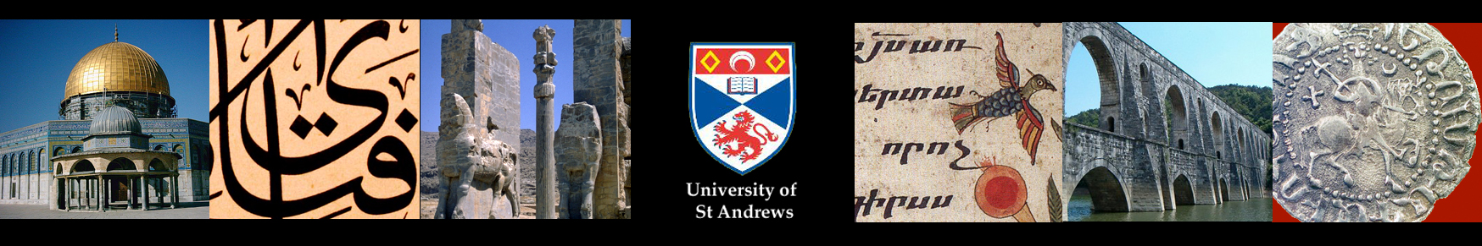
MIDDLE EASTERN AND IRANIAN HISTORY
SEMINAR SERIES
Semester Two 2018/19
Thursday 28 February [Week 5] 5:15pm Old Seminar Room, 71 South Street
Adam Talib (Durham)
Narratives are for suckers: 21st-century cinema, Renaissance Self-Fashioning, and a Late Antique Revenge Tale

Thursday 7 March [Week 6] 5:15pm Old Seminar Room, 71 South Street

Foteini Spingou (Edinburgh)
Helen of Troy and the Crusaders: classicising visions of Constantinople in 1204

Thursday 14 March [Week 7] 5:15pm Old Seminar Room, 71 South Street

Francesca Leoni (Oxford)

Thursday 4 April [Week 8] 5:15pm Old Seminar Room, 71 South Street

Ronie Parciack (Tel Aviv) Tel Aviv Exchange Fellowship 2019
West Asia, South Asia: Travels to the other side of the Self

Thursday 11 April [Week 9] 5:15pm Old Seminar Room, 71 South Street

Iain Gardner (Sydney)
The Project to Edit the Chester Beatty Kephalaia Codex and What it can Tell Us about Early Sasanian Iran

Thursday 18 April [Week 10]

Siavush Randjbar-Daemi (St Andrews)
Beacon of Diversity: Ayandegan and the Iranian Spring of Freedom of 1979

Thursday 25 April [Week 11] 5:15pm Old Seminar Room, 71 South Street

James Barr (KCL)
Anglo-American rivalry in the Middle East in the quarter-century after 1942

All Welcome

